Task – 8

Webserver is running fine
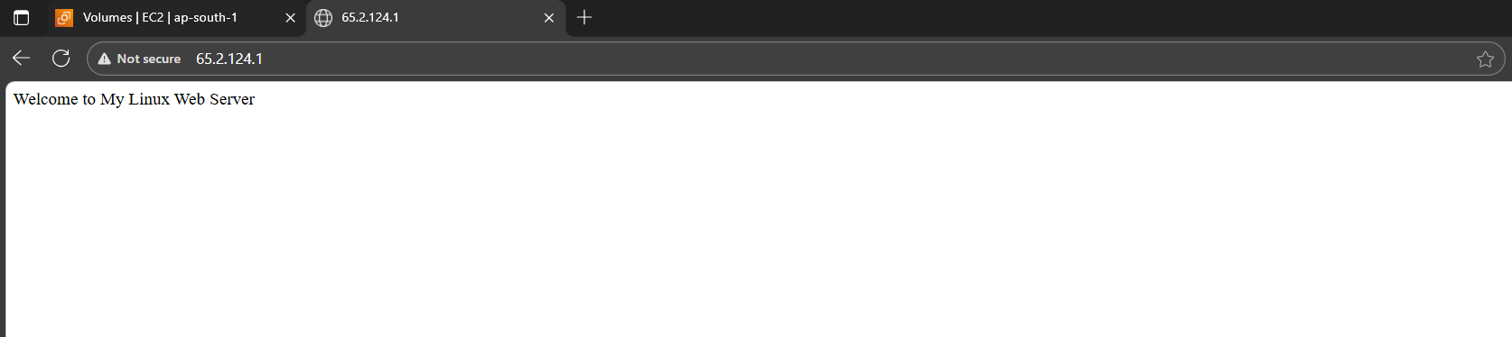

New volume created and attached to the instance
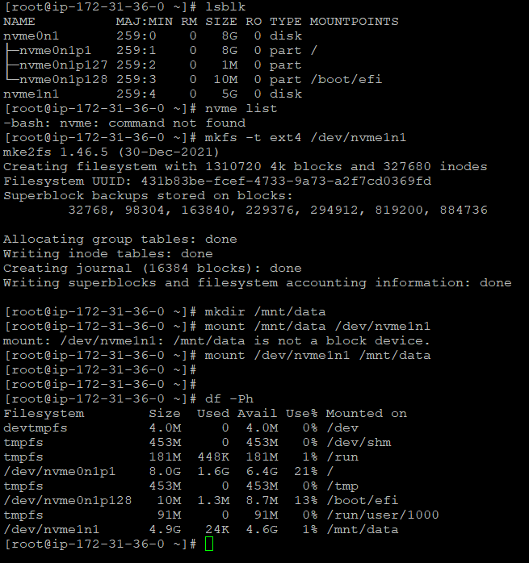
Snapshot created
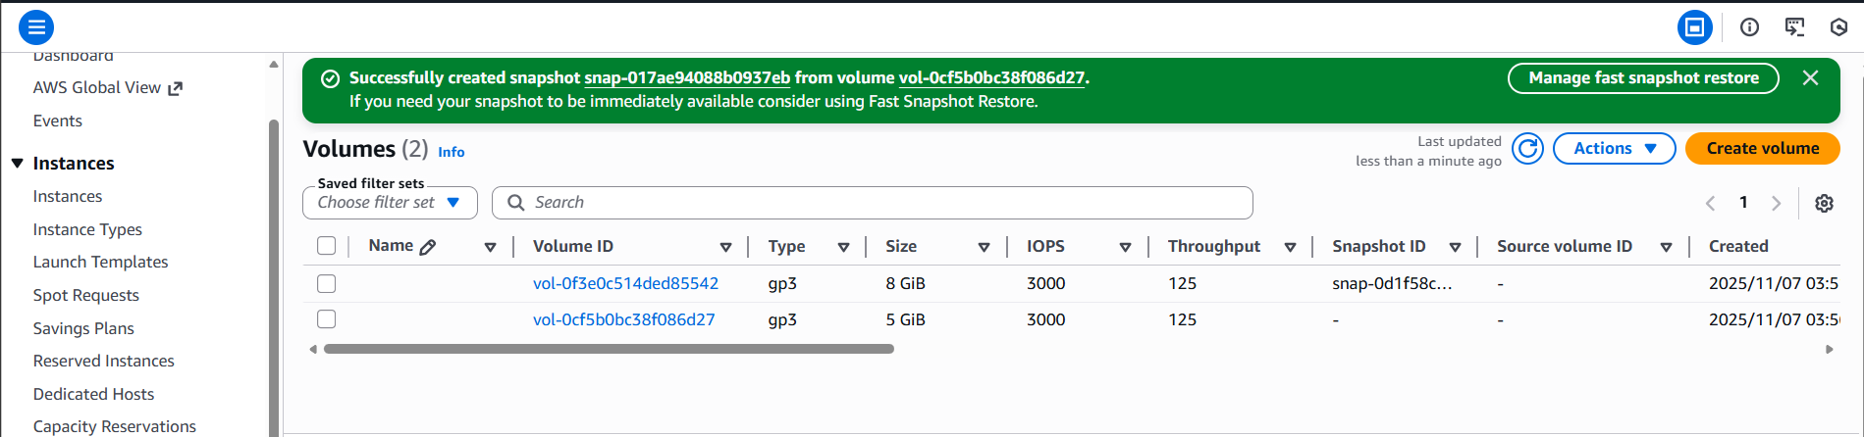
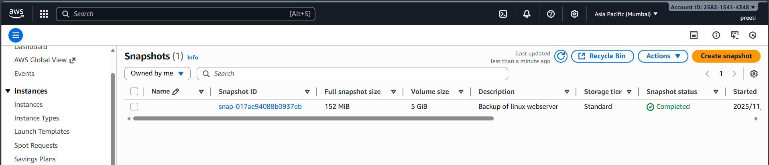

Volume created from snapshot
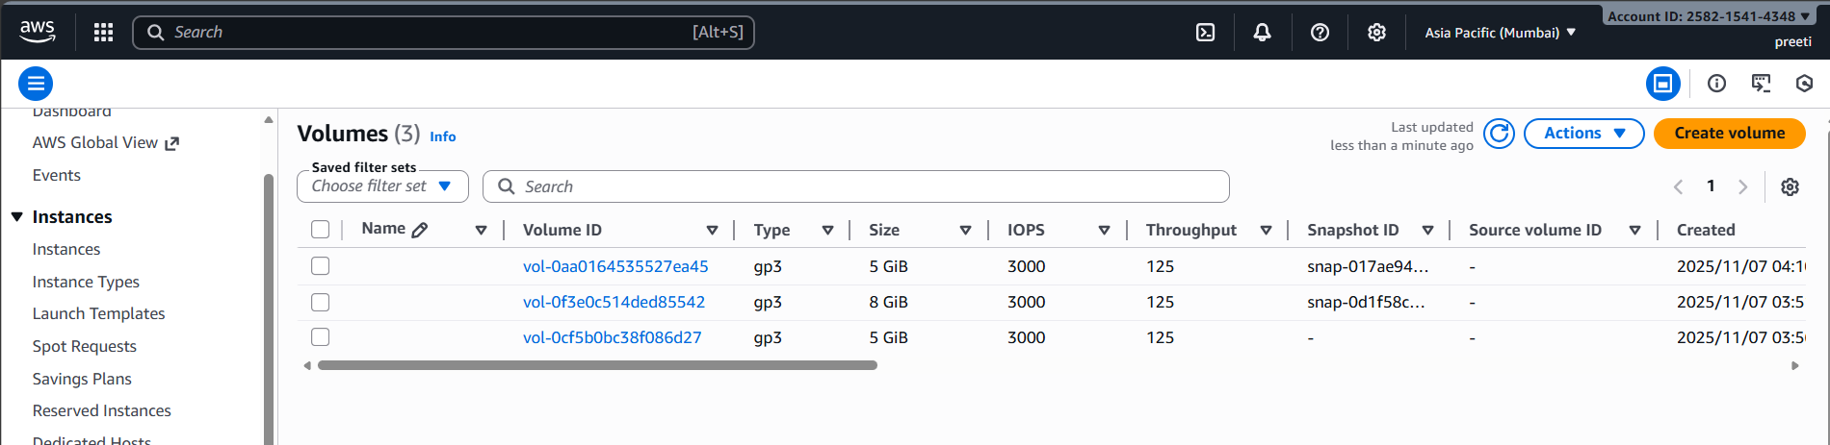

Windows webserver
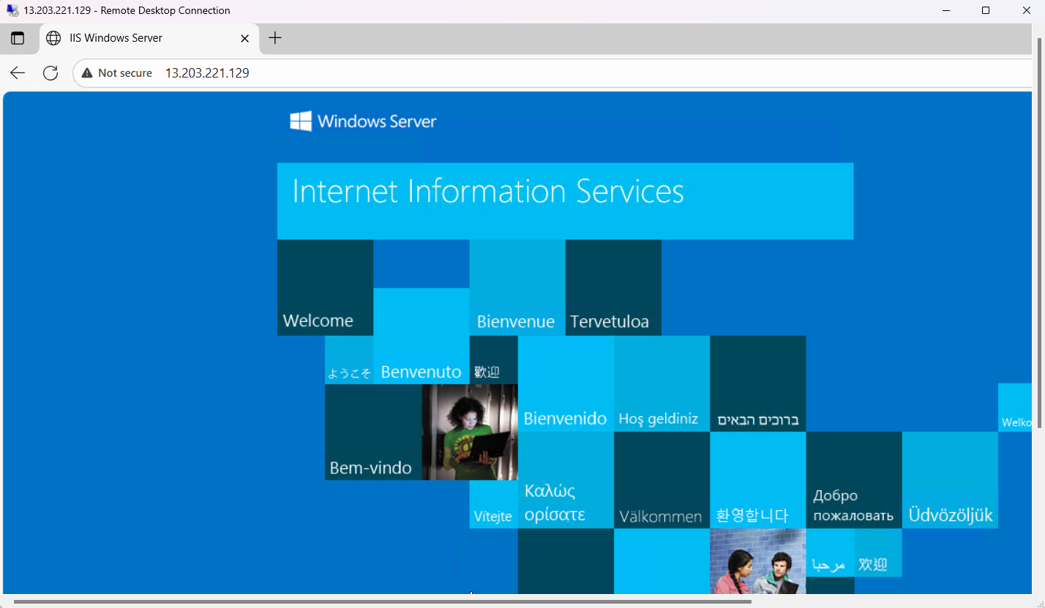
Volume added to the windows webserver
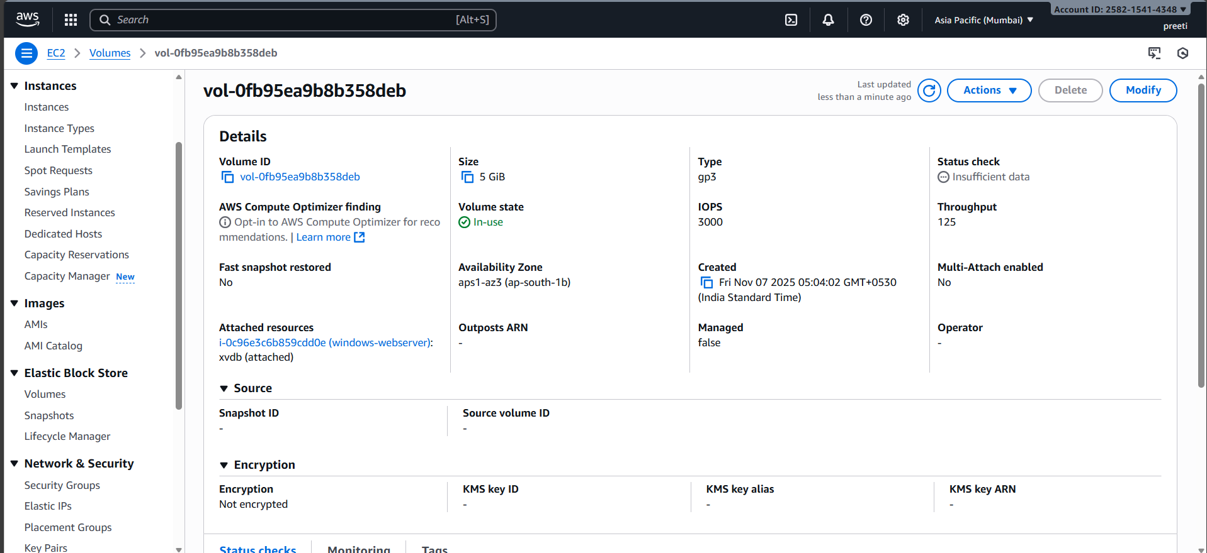
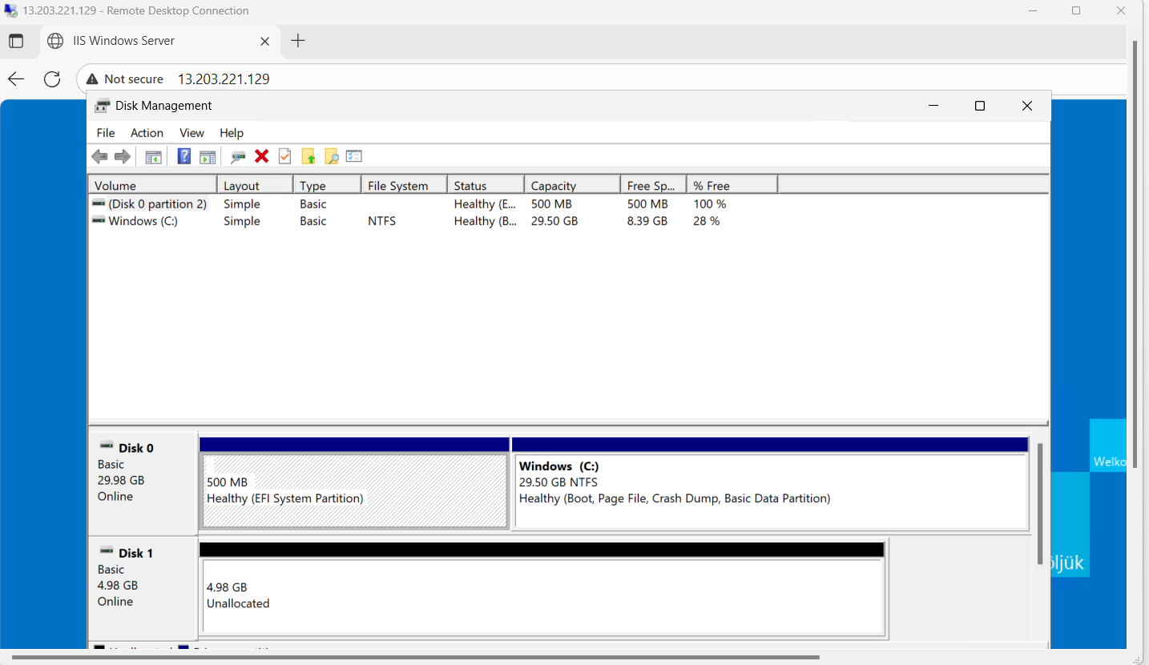
Snapshot created for the volume created
